Activity 5

Mohamad Ali Ghaddar

Questions:

1. There are 8351 dog images in the dataset.
2. I used 100 epochs.
3. I used my own CPU & GPU for the training on MVS code.
4. 1555 minutes.
5. I used 5 images:

Image 1:

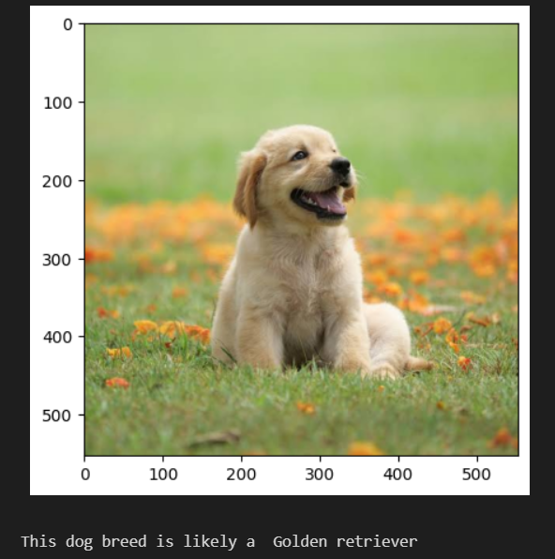

Real type: Golden retriever

Image 2:

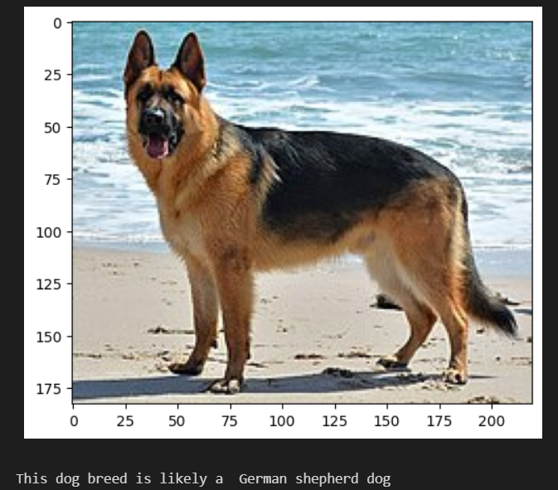

Real type: German shepherd

Image 3:

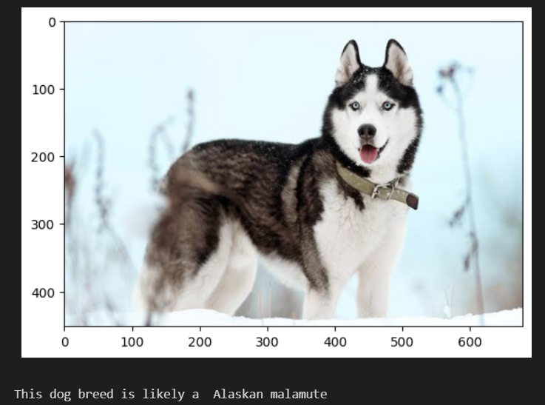

Real type: Siberian Husky

Image 4:

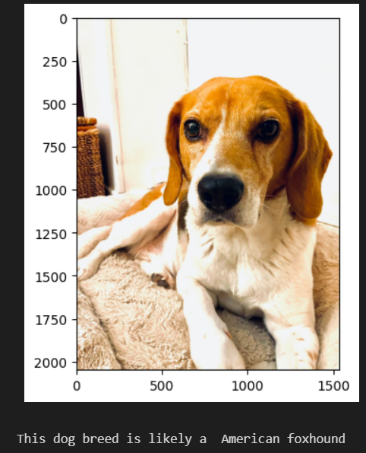

Real type: Beagle

Image 5:

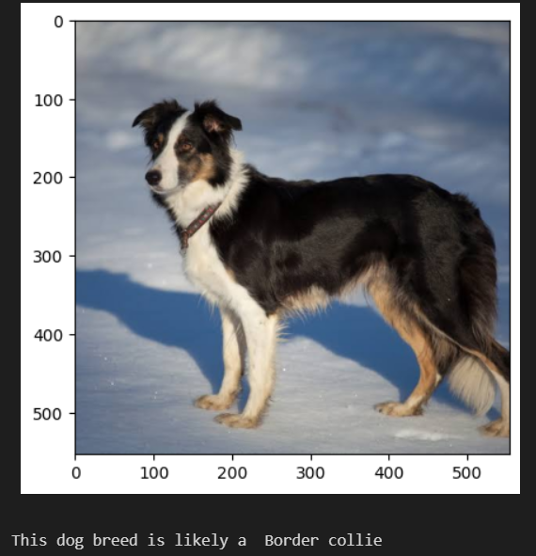

Real type: Border collie

3/5

1. Colab attached (cnn_transfer_resnet50).

I used resnet50 to replace VGG16, I had to replace VGG16 by resnet50 in the code and for the image transorm parameters I had to input the correct standard deviation and crop that are compatible with resnet50.

I also had to update the classifier since it isn’t available in resnet50 and replace it with the function linear.

I also had to update the criterion_transfer and the optimizer_transfer functions.

The rest of the code remains unchanged.

Comparison with VGG16 (resnet50 was only trained for 10 epochs):

Image 1:

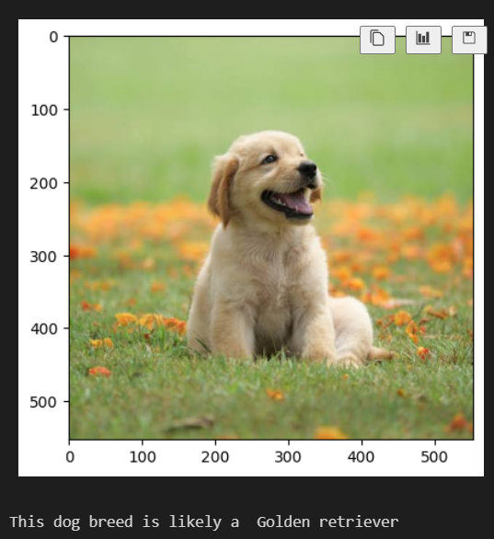

Real type: Golden retriever.

Image 2:



Real type: German shepherd

Image 3:



Real type: Siberian Husky

Image 4:

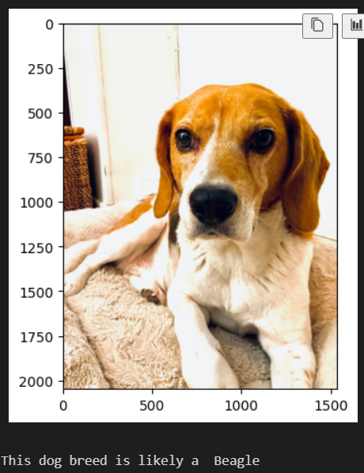

Real type: Beagle

Image 5:



Real type: Border collie

4/5 better than VGG16

1. Colab attached (cnn_transfer_resnet50).

I added a submodel at the end of the resnet50 code using the pretrained model Yolov5, this model is capable of multiple detections in a single image, I needed to add the model as model_transfer, rewrite the dog detection function with yolov5, add a loop to read multiple dogs in a single picture using opencv (cv2) and at the end we can print out the results.

Example:

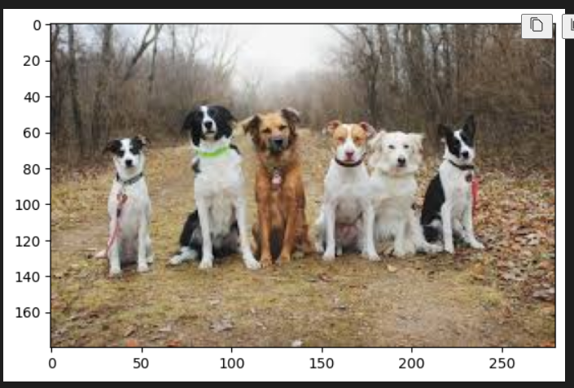

Results:

Dog 1 breed: Japanese chin

Dog 2 breed: American foxhound

Dog 3 breed: Australian cattle dog

Dog 4 breed: Australian cattle dog

Dog 5 breed: Australian cattle dog

Dog 6 breed: Pekingese

Results in the code:

